Nikhil Patel, 38539144

**Peripheral Vision Displays: Creating an Unobtrusive LED Notification and Navigation System for Glasses**

B.Sc. Computer Science

School of Computing and Communications Lancaster University

//DATE OF SUBMISSION

Notes:

Purple highlighted = addition with reference to comment

Dark yellow = wording that needs to be changed with yellow.

Yellow = wording needs to be replaced with what is previously written

Green = good work

Red = remove after rework and important

Blue = check work

//I THINK THAT THE WHOLE PAPER HAS TO BE WRITTEN AS ITS ALREADY BEEN FINISHED. CHECK WITH PAUL BUT I THINK ITS SUPPOSED TO BE LIKE THE ABSTRACT SECTION OF THE EXAMPLE

// MAKE SURE TEXT IS THE FULL ONE INSTEAD OF LEFT ALIGN

# Declaration

I certify that the material contained in this dissertation is my own work and does not contain unreferenced or unacknowledged material. I also warrant that the above statement applies to the implementation of the project and all associated documentation. Regarding the electronically submitted work, I consent to this being stored electronically and copied for assessment purposes, including the School’s use of plagiarism detection systems in order to check the integrity of assessed work.

I agree to my dissertation being placed in the public domain, with my name explicitly included as the author of the work.

Name: Nikhil Patel

Date: //ADD DATE

# Abstract

//This project has developed an alternative method of receiving notifications and performing navigation.

This project aims to develop an unobtrusive notification and navigation system using a ring of dim LEDs around the frame of glasses to shine at the user’s peripheral vision when the connected phone receives a notification or a navigation command. //maybe add another aim?

//another aim = makes the user not focus on their phone and so is a safer alternative but also feels like an extension of the user and allows for multitasking as hands are now free.

The resulting device provides an easy to understand and cost-effective prototype solution designed for hobbyists. The system works through the use of a LED display that connects to a nRF52840 microcontroller, which the user’s Android phone communicates to using Bluetooth Low Energy (BLE).

This project aims to develop an unobtrusive notification and navigation system using a ring of dim LEDs integrated into glasses frames, shining at the user's peripheral vision. The design focuses on providing an easy and cost-effective prototype solution, addressing the limitations of current navigation methods. The implementation involves creating a functional LED display, ensuring it is unobtrusive, and establishing a connection between an Android phone and an embedded system through Bluetooth. The primary contribution is a novel approach to navigation, leveraging peripheral vision to enhance user experience and safety. Findings from participant testing will evaluate the prototype's effectiveness compared to existing approaches, emphasizing its potential impact on spatial awareness and multitasking capabilities.

# Contents

Declaration 2

Abstract 3

Contents 4

1. Introduction 6

2. Background 7

2.1. Peripheral Vision Display Concepts 7

2.2. Feedback Methods / Information Channels 9

2.3. Direction / Orientation Detection 9

3. Design 11

3.1. System Requirements 11

3.2. Architecture Structure 11

3.3. LED Design 12

3.4. GUI Design 13

3.5. Code and Library Design 14

4. Implementation 16

4.1. Mobile Application Implementation 16

4.1.1. Direction / Orientation 16

4.1.2. Bluetooth 16

4.2. Peripheral Device Implementation 17

5. Testing 18

5.1. User testing 18

5.1.1 Risk assessment 18

5.1.2. Testing Procedure 18

5.2. Research Methodology 18

5.2.1. Qualitative Data 18

5.2.2. Quantitative Data 19

5.3. Battery Life 19

6. Evaluation / Results 21

7. Conclusion 22

7.1. Review of Aims 22

7.2. Future Work 22

7.3. Revisions of Design and Implementation 22

7.4. Changes from the Proposal 22

7.5. 22

References 23

Appendix 1 – Project Proposal 24

# 1. Introduction

The overall aim of this project is to implement and test the usability of users’ peripheral vision to improve the user experience of navigating to a desired destination with being less obtrusive than carrying a mobile phone to check directions.

# 2. Background

//when referencing, just add the title of the paper and then in brackets do citation for the people in the paper.

## 2.1. Peripheral Vision Display Concepts

The concept of a peripheral vision display, as explored in a paper on ‘Smart glasses with peripheral vision display’ (Nakuo, Kunze, 2016), involves a device designed to facilitate ‘implicit and explicit interactions’ by displaying patterns in the user's peripheral vision. Their prototype aimed to control human motion unconsciously and ‘alter walking speeds and motion’ using a grid of LEDs. Although using a grid of LED’s would allow for a different testing environment, this project focuses on utilizing a single array to simplify user interaction, eliminating the need for animation patterns and instead replacing it with simple light commands that the user should be able to learn and easily follow. The paper mentions technical problems with the project being limited brightness as having poor visibility of the LEDs. This will affect certain scenarios such as use of the device in daytime. With this project, I will ensure the LEDs situated in the user’s peripheral vision are bright enough for daytime use but also dim enough so that it is not distracting the users away from their focal vision as it may lead to unwanted risks and to increase wearability of the glasses throughout the day. This will be tested and evaluated with multiple participants in real-world scenarios. An improvement mentioned in the paper was the idea of attaching 2 LED matrices for each eye which would likely benefit the effectiveness of the glasses however, this project is likely to benefit more from an LED arrangement that will utilise the user’s whole peripheral vision.

Another paper which also designs a peripheral vision display is one called ‘Ambiculus’ (Lubos et al., 2016). They created a display extension to the Oculus Rift DK2 by adding RGB LEDs and diffusing foil to extend the visual field. Although the peripheral visual quality was worse than the central field in the head mounted display (HMD), there was still an improvement in the user’s subjective sense of presence which influenced behaviour when participants navigated through a 3D virtual environment. Although the paper mentioned focuses on further development for HMD’s, I found some of the technical problems important to note for this project. One challenge was with some participants reporting increased simulator sickness with the additional peripheral light. This is something that will be very important to test with my project as the addition of the peripheral light being used in real world scenarios may increase motion sickness. This project is likely to benefit user’s behavioural changes with it being implied from the paper that users had increased head movements due to user not needing access to their smartphone while using the display for directions or notifications. There aren’t many improvements to take from the paper mentioned as most of the issues come with using LEDs to extend the OLED of the “Oculus Rift DK2” but one that may benefit user experience, is through testing a range of visual cues to analyse which are the most visible and effective for the context of this project.

In an article that explores and tests “eyeglass peripheral displays for subtle intimate notification” (Costanza et al., 2006), the authors present a new approach to address the challenges posed by disruptive mobile notifications in public spaces. Their design involves integrating a discreet display of red and green LEDs, offering users a means of receiving notifications that are noticeable without being too distracting. The product prioritised customisation, providing users with the flexibility to adjust the brightness and speed of the LEDs moving patterns. They also found that using the Bluetooth controlled device to communicate to the user’s phone, proved to be an energy efficient alternative to conventional vibrating motors. The experiments conducted demonstrate the effectiveness of peripheral cues in various everyday activities such as editing text while walking and reading. From these experiments, it was concluded that the device tended to be less noticeable under high workload conditions which aligned with the goal of minimizing disruption during focused tasks. Although the study focuses on the visibility of cues, it doesn’t extensively explore the impact on primary task performance such as navigation which this project will also focus on. As my product will be designed for outdoor use, ensuring that the notification system aligns with diverse social norms is important for evaluating the viability of the peripheral vision display.

One issue with the idea of using a peripheral vision display to help users with navigation is the idea of how well people will be able to adapt to the product in real life. This isn’t something that I will be able to test as it may take users weeks to months of consistent use to get used to it and so further research will have to be done after the projected timeframe of this project to see if it can be a viable option or is using a phones navigation app directly, the better option. It has already been noted that people with lack of peripheral vision will not be able to use the product or gain any benefits from it but people with blurred peripheral vision may as it isn’t a shape that is being produced from the LEDs but a light. It should also be noted that a normal visual field is approximately 170 degrees, with 100 degrees comprising the peripheral vision (Dr. William Goldstein, 2013). With this information, I need to make sure that the LEDs are placed somewhere between the mid and near peripheral vision otherwise the user will not be able to see the light shine. The further the placement in the field of view, the less distracting it will be but the more likely the user will miss the light.

^ this might be going too much into design

Shifting the users focus from their phone during navigation to their surroundings has many benefits when it comes to the safety of the user as the visual stimuli can shift users’ attention without cluttering the main visual field. An example of this being observed is in a research paper named ‘Guiding Smombies’ (Gruenefeld et al., 2018), which tested augmented peripheral vision to support pedestrians in critical traffic encounters while using smartphones. Although the experiment was with using a treadmill to evaluate effectiveness of collision warnings with different light stimuli, there was 100% correctness with light stimuli being easily perceivable and moving stimuli resulting in significantly faster response times than instant and pulsing stimuli. Although true, subjective feedback indicated that participants found all stimuli alarming and as this project doesn’t require fast response times, the user shouldn’t find a large difference in effectiveness between different stimuli. It would be a beneficial for users to have the option of choosing what stimuli they prefer through settings on the smartphone. The study successfully demonstrated the effectiveness of peripheral vision augmentation in shifting the attention of smartphone users to improving pedestrian safety in context of smartphone usage in critical traffic situations, which can be applied to applications in less critical situations such notifications and navigation.

## 2.2. Feedback Methods / Information Channels

A study that explores 6th senses and the use of different feedback methods in pedestrian navigation systems (Pielot et al., 2011) discovered that tactical feedback helps reduce distractions whilst multimodal feedback improves navigation. It suggests adjusting tactile feedback to avoid unnecessary cognitive load. The research also found that using a single actuator for directional cues is effective in aiding navigation, although there were no significant differences observed. Participants showed a slight decrease in navigation performance with tactical cues, likely due to being more confident with visual systems. Participants found visual feedback led to more frequent map checking when asked to reach their destination under different modes of feedback but also resulted in a significant increase in walking speed. The study mentions using a combination of different feedback methods improved navigation performance by reducing errors. This means that it may be beneficial to use both LEDs for visual feedback and phone vibrations for tactical feedback, but the paper also mentions that tactical feedback increased cognitive workload as evidenced by slower walking speeds.

Using LEDs instead of other information channels is mainly influenced by the environment which the user would use the system. This project’s focus is navigational aid and so is designed for outdoor use meaning sound and vibration as information channels would be a very poor choice to send information to the user as there is likely to be loud noises from the environment that will be hard to distinguished if played aloud, resulting in a less intuitive experience. One solution to this is to use headphones but this decreases usability. It should also be noted that both sound and vibrations are very limited information channels more so than using LEDs in the view of this project. This is because LEDs allow for multidirectional cues whereas the other options can only change intensity and speed at which they are played. If I was to use tactical feedback in the form of vibrations, I need to make sure that they simple but also distinctly recognisable in contrast to regular phone vibrations to hopefully decrease cognitive workload and to improve interpretation such as mentioned in the paper.

## 2.3. Direction / Orientation Detection

‘SOMDA (Smartphone Orientation and Movement Direction Alignment)’ is an approach to orientation which aims to accurately detect the movement direction and orientation of users carrying their mobile device inside trouser pockets. This is an important concept to implement to this project using peripheral vision to aid navigation as having the user receiving updates from their glasses removes the need for the user to have their phone out. This means that the user will not be independent from their phone and so the sensors that calculate orientation and bearing will have to be calibrated for user specific conditions. A paper dedicated to explaining and testing ‘SOMDA’ is called ‘Direction Detection of Users Independent of Smartphone Orientation’ (R. Kusber et al., 2015). Their results of testing ‘SOMDA’ achieved an accuracy of 96% with a threshold of 15 degrees using a sampling rate of 50Hz and found accuracy to decrease slightly when using lower sampling rates. ‘A-GPS’ is an alternative mention in the paper used to detect movement directions using existing servers to get more accurate readings of the user’s location, and compared to the previous concept, ‘SOMDA’ significantly reduces time required to detect changes in user orientation and movement direction with detecting complete turns on average being 3.4 seconds faster than ‘A-GPS’. As implementing ‘SOMDA’ would be time consuming to implement and is likely to be hard to include, ‘A-GPS’ will be used initially to get user location as an alternative if I cannot implement ‘SOMDA’ later.

//colour theory for the leds

# 3. Design

* Here are my requirement specs
* Architecture structure
* What talks to eachother
* All the stuff before writing code
* Sensors and what they do
* Google api
* All the libraries
* Design of UI
* Design of glasses

//Software – asked paul so lets see

* Java – android studios
* Google maps sdk

Circuitpython

The hardware that I used for this project included a nRF52840 Bluetooth LE microcontroller bundled with Adafruit EyeLights LED Glasses which uses a IS31FI3741 LED driver chip.

## 3.1. System Requirements

//check if I need to mention that the microcontroller and the glasses were bundled

The smartphone used to run the Java application requires a minimum Android level of ____. Android was used as integration with libraries such as Google Maps SDK for Android being used for the navigation function of the application. The device that was used during development is a ‘OnePlus 7 Pro’ as it uses a magnetometer, gyroscope, and Accelerometer to calculate compass direction. Aside from the smartphone, the project requires an nRF52840 Bluetooth LE microcontroller and Adafruit EyeLights LED Glasses. The choice for using nRF52840

## 3.2. Architecture Structure

The architectural structure of the project’s components includes a battery, android application, microcontroller, and LED glasses. Having a small number of manageable parts to the project allowed for better separation of tasks for the smartphone and microcontroller. An alternative which was created before knowing what microcontroller I would use, involved sending messages through WiFi which would’ve likely needed me to create and set up the projects own peer-to-peer network and router configurations which would be a larger learning curve than using BLE. Instead, I opted to use BLE (Bluetooth low energy) as it was more efficient for battery power which aligns with my requirements. In addition to this, there is better privacy and a cheaper deployment cost, but this comes with a negative with their being lower speed which is said to be “about 2-3 time slower than Bluetooth Classic and 20-30 times slower than Wi-Fi Direct” (Arun AG). Evaluating both options, settling with BLE seemed to be a better option for my use case as the distance between the smartphone and the microcontroller is very small, the costs are cheaper and, lower speeds shouldn’t have much noticeable effect depending on the structure of the messages being sent.

## 3.3. LED Design

Using an Adafruit EyeLights LED Glasses, allows for structure of LED’s that can be called individually. For the LED’s that will be utilised, the two rings around the users’ eyes are the only ones used. I evaluated this being the best LEDs to utilise as the ones placed where the eyes are and the space in between the two rings, are too distracting and largely affects the user’s focal vision which is dangerous. As I limited myself to the two LED rings, it made it easier to assign sections of the LEDs to symbolise different commands for the user and the ability to use colours. Each of the rings include assignment for 25 lights which I used to create associated commands for navigation and notification.

The final version that will be used as the default LED states is shown in figure 1. The reason for this being the final version is because it uses multiple colours which indicate different functions that can be memorised easily. The first version of the design for the different commands included using red and blue primarily as they’re the most contrasting colours against each other and was also beneficial for colour blind individuals. The previous design for notification also included lighting the entire left and right rings with red but this was very distracting compared to the other commands which are more important but were viewed as more subtle. I felt that having notifications to be less distracting than the navigation commands would’ve been a better fit as they are not as important. Not included in figure 1 is the indication that the phone has been paired to the microcontroller. When this occurs, the right and left LED rings are both lit up green.

To also make it more obvious when the glasses are still working in idle mode (when the device is connected), I designed the microcontroller itself to constantly shine green on the onboard NeoPixel as it gives an unobtrusive indication of state. Besides showing when the device is connected, I also created 2 more states for the NeoPixel being blue and red which works in tandem with the LED state shown in figure 1 on the glasses, and a yellow shine when the user’s settings from the smartphone are being processed.

// talk about how the leds can change brightness

//talk about how adding ability for the user to choose what colours they would like.

Also talk about movement of leds.

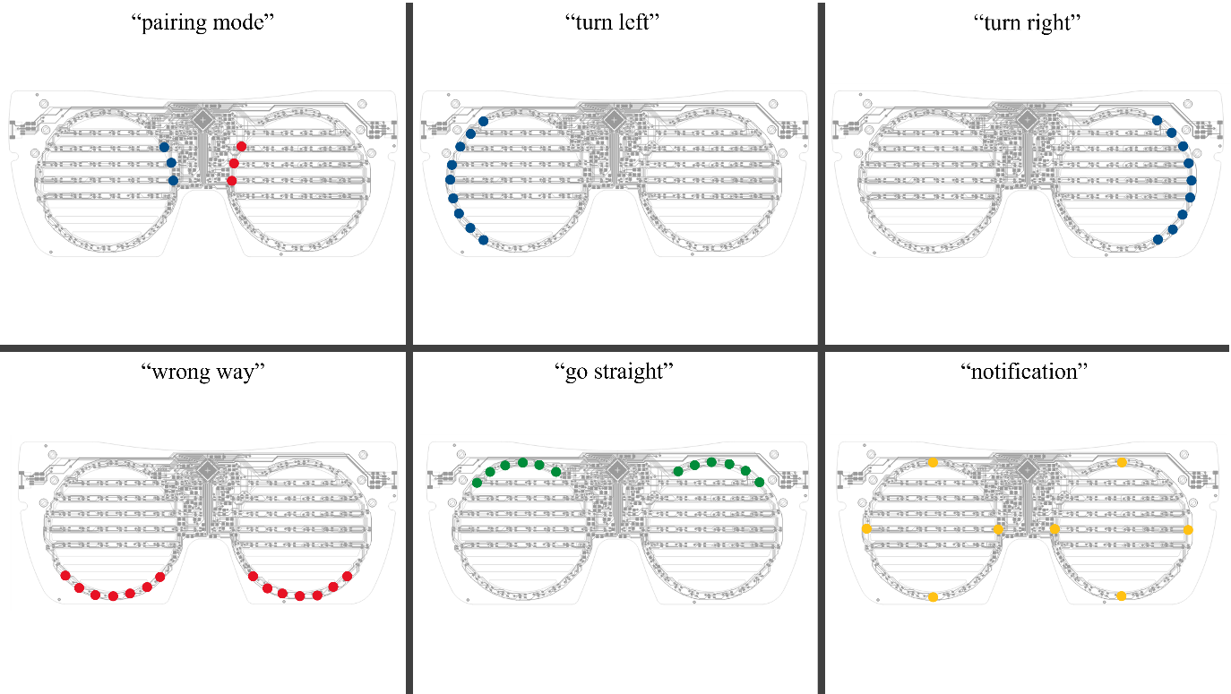

Figure 1: Default LED States

When setting up states for the microcontroller and how it connects to the mobile phone, I altered the view of pairing mode from the microcontroller. Preivously, I designed the LED to shine red and toggle between on and off. At the time this was a good simple pairing mode but when the microcontroller gets an error, by design, the LED flashes red in a very similar way which will be confusing for users. To change it, I decided to use the NeoPixel embedded into the microcontroller and toggle between being red and blue. This seems to be a more obvious combination of colours that indicates a pairing mode.

## 3.4. GUI Design

<https://developer.android.com/design/ui/mobile/guides/layout-and-content/layout-basics>

To present the product in a way that allows them to easily access all the individual features of the application, usability was taken into consideration to change the design of the application. Previously, the design of the app was made solely for development purposes meaning many debug texts were kept which would help the user know the state of the processes but also made it a less enjoyable experience. An example of the previous version of the individual pages are shown in Figure 2. This design was used as it was quick and simple to get to the Maps page before the addition of the Bluetooth page and the Settings page. Previously, the Bluetooth page was not needed as the code was designed to automatically connect to the device based on the name and the address of the design. This wasn’t a good implementation as the device to be connected to was hardcoded meaning if the product was to have multiple productions, the owner of the system would have to replace the variables in the files manually. The settings page was a new addition to the program and so benefited from the navigation menu as it means it isn’t restricted by the flow of the program. The new versions of applications GUI designs are shown below in Figure 3.

Figure 2: Previous GUI Designs

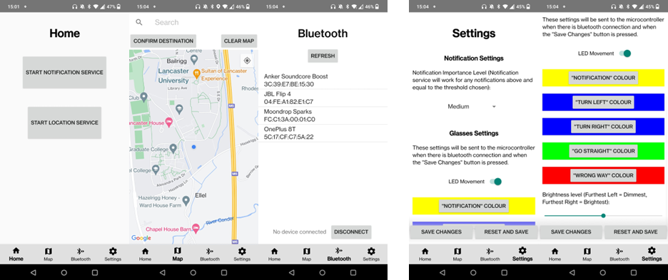

Figure 3: Updated GUI Designs

## 3.5. Code and Library Design

To match with the hardware that was used, the smartphone application required development on either Kotlin or Java, both being available languages on Android Studios which was the IDE of choice. Java was chosen primarily from proficiency in the coding language from previous coding projects which mitigated the need to learn a new language. As the application requires a maps system for the navigation feature of the project, Google’s Maps SDK for Android was used. During the beginning stages of development, instead of Googles services, an open-source alternative named “OpenStreetMap” was used. The reason for changing to Google’s services, mainly stemmed from easier integration with Android Studios, better understandable documentation, and features which made turn by turn directions easier to implement through using Google’s Directions API was used. Using Google services also helped to add the navigation menu shown in figure 3.

On the other hand, the nRF52840 microcontroller supports two languages being CircuitPython or Arduino. CircuitPython was the language of choice as I have previous experience with Python but also from the Arduino language being based on C/C++, which is faster and more efficient but much more complex and has a steep learning curve which would’ve taken more time to learn and use.

# 4. Implementation

* What I did to make it work
* 2 sections to break it down for phone and peripheral
* Talk about code for bluetooth connection. + only talk about code on this,

## 4.1. Mobile Application Implementation

With the purpose of the mobile application being to start services that will then communicate with the BLE peripheral (maybe add the name instead), I

### 4.1.1. Direction / Orientation

Handling user direction and making sure they are walking in the correct orientation to each turn-by-turn point was a concept that took a large time to incorporate. Many different implementations were used, beginning with creating a calibration system on the smartphone which involves the user facing true north, pressing the calibration button and in 10 seconds, placing the smartphone in their pocket. The system will then use the new result of the pockets orientation as the new value for north. The reason why this didn’t work was because smartphones use a combination of a magnetometer, gyroscope, and accelerometer to determine orientation which added more variables that the calibration system didn’t consider during use making it very inaccurate. It was both inaccurate when placed in the pocket and facing a direction without moving and worse when moving as lifting the leg changed the sensor data to be completely wrong to orientation of the user. To fix this, I decided to use SODMA //insert cite but the implementation of it wasn’t finished as it ended up being time consuming due to its complex nature as it needed me to create an algorithm that I have no understanding of. Finally, the orientation method that was created didn’t directly use any of the orientation sensors but instead took the location of the user during a walking state, and for every step, added the data to an array. After every 4 steps, the average bearing was calculated, and the array was cleared. The result is then compared to the bearing of the first location in the array to the current step destination to check if the user was walking in the correct direction. This implementation showed very accurate results compared to the other versions.

### 4.1.2. Bluetooth

To implement the use of Bluetooth to connect the smartphone to the microcontroller, I used the Android development website as a reference to create my system (Android, 2023). This was a straightforward guide but there were some stages that were found to be challenging. The final version of the Bluetooth connection system starts with listing available devices in the area. The information of the devices name and address are both used to try and connect to the device.

// checks the characteristics of the device to send the messages across

// uses a queue to send messages so that they aren’t concatenated in random places.

## 4.2. Peripheral Device Implementation

There were many limitations that stemmed from the circuit python language not supporting threading. This included issues with animated lighting and brightness changing. To overcome the issue with the animated LEDs, I had to find an alternative to threading using CircuitPython. This led me to use yielding as an alternative. Yeilding resulted in the animations working but, in some cases, having a slight delay between LEDs lighting. This shouldn’t affect the user experience as the LEDs will be in the users peripheral vision as there is less visibility. The other issue mentioned being with brightness changing, had an issue where due to the lack of threading and there being multiple time.sleep() function calls which stops the current process until a duration of time. There was no possible way of changing the brightness whenever the user wanted and instead required the user to time when to press the onboard button for it to trigger a function. The usability of this was very poor and so an alternative was made by utilising the previously written code for applying settings from the smartphone to the microcontroller.

An issue that arose from using the previous written code was that I was already sending a message which was the maximum allowed size. This meant that I had to design the brightness setting to be sent separately after the first set of settings was sent. When the message was received, I checked its format and then ran a function which used the converted byte into int form which corresponded to the index of the array which holds the fixed brightness settings. The brightness setting doesn’t affect the onboard NeoPixel as the main thought process behind changing the brightness would be for the glasses themselves instead of the microcontroller which isn’t visible to the user when the glasses are worn.

# 5. Testing

Test how long the batteries can last – show the battery life

## 5.1. User testing

### 5.1.1 Risk assessment

A risk assessment was carried out //CHECK IF I NEED TO ADD THIS IN APPENDIX for the experiment as there are potential risks from the design of the glasses. These risks include the user having obscured vision due to the horizontal bars from the LED display and the LEDs themselves being designed to shine in the user’s peripheral vision which may cause distractions. These risks are elevated as the experiment will be taking place in a public space, and so the participants safety will be ensured during the navigation through the experiment conductor warning the participants on any hazards as they may come. Before the participant is asked to undergo the experiment, they are taken through the risks that may happen during navigation and are asked to sign the consent form if they are comfortable with proceeding with the experiment. If the participant is uncomfortable with carrying out the experiment, they can stop at any time.

### 5.1.2. Testing Procedure

The experiment will start with the user receiving a brief tutorial and explanation of how the system works, which includes the user being shown how to change the brightness of the LEDs and setting it to their level of comfort. After the user feels comfortable with being able to perform the experiment, they will be given the devices and will be observed to see if they are able to perform set instructions. At any stage, if the participant is confused or is having trouble with the system, assistance will be given. Observation of all the features of the application will be directed to if the user doesn’t naturally use a feature of the system. This is to make sure that individual participant data can be compared to gain accurate results of their experience. Included in one of the tasks, the user will be asked to enter a location on the device and to navigate to that destination without the aid of seeing the smartphone during the navigation. The smartphone will be placed in the user’s pocket and if needed, the user will be allowed to briefly use the device. The reason for performing the navigation task like this is to make sure that the participant is relying on the glasses to navigate themselves to the destination and not the applications map system. This is so that we can compare the usability and effectiveness of using a peripheral vision display for navigation and notification instead of a smartphone application alternative such as google maps.

## 5.2. Research Methodology

### 5.2.1. Qualitative Data

In the form of qualitative data, the participants will talk aloud their thought process throughout the duration of the experiment. This is to understand the users experience when using the system and issues that they may face. These can be used to find improvements for all parts of the system. The notes taken will be selective based on information that is directed to the project and will be shown to the participant after the experiment has been finished to make sure they are comfortable with what has been written.

A survey will take place after the experiment has been conducted to gain better understanding of how the participant found different parts of the system and if there were any changes that they would recommend being made. It will also be used to understand what aspects the user finds good about this system in comparison to smartphone only alternatives such as google maps. These results will help evaluate the usability and the effectiveness of the device in all its individual sections.

### 5.2.2. Quantitative Data

To test the accuracy of the glasses and the navigation system, I created a system with the application that records the user’s location during a walking state every 5 seconds through adding markers on the map. This is to help show the deviations in the user’s path towards the destination and if they were able to correct themselves when walking in an incorrect path. The results will help evaluate the accuracy and usability of the product. The map with the users’ locations will be screenshotted when the participant reaches the end destination. During the observation, the number of times the participant receives messages for “wrong way” and “go straight” will be recorded to also help determine accuracy.

## 5.3. Battery Life

The nRF52840 microcontroller is capable of being powered from 3x 1.5V-AAA batteries. To test the battery life of the microcontroller, code was created on the smartphone to send notification messages every 2 minutes to the microcontroller. As the design for the LEDs to shine when receiving a notification only uses 8 individual LEDs, testing the battery life of the device through shining all the LEDs on both eye rings was the better choice for finding the power consumption and minimal battery life of the device.

The results were

5.4. Personal Testing

Before testing other participants, I tested my product with the tasks that I would ask the participants to perform. This testing occurred when the glasses were finally built, and the software was ready for participants. This test was insightful for finding many issues with my code that couldn’t be looked past. These issues included:

* The glasses saying the user was going the correct direction but when the user walks in the correct direction, it tells the user that they are going the wrong way.
* Having to look at the smartphone multiple times because it was confusing where the correct path was, if there are multiple turn points in a small area, the device thinks that the user has already hit them and so makes it very confusing where to go.
* When turning at a bend, because the user is not taking a 90 degree turn but a gradual one, this makes the application think that the user is walking in the wrong direction.
* The user’s location randomly teleports the user to somewhere that the user isn’t which messes up the application by saying the user is walking the wrong way when they are.

Many of the errors that stemmed from my location being incorrect may be due to the sensors on the smartphone not being accurate enough to support navigations like this or another reason may be due to the test being from the InfoLab21 building to Cartmel college at Lancaster University which are both places situated further away from the main part of the university, resulting in possible poor GPS signals.

Besides the errors found, I also found many areas of improvement for better user experience which included letting the user know more about when features have been activated and simple changes such as making the projects peripheral device to have a light green colour under it to indicate to the user that they should connect to it.

# 6. Evaluation / Results

// does the user find the correct directions

// do they want more feedback from the app or lights?

//what questions am I trying to answer. What results do I want to evaluate and how it works?

Participant 1:

When testing with the first participant there were a few issues that were found with the application that needed to be fixed before testing with other participants. The main changes necessary being with the system finding it difficult to hit step destinations if there was no path on Google maps. This is not an issue from my code but due to the use of Google services placing step markers on the road if it doesn’t see a pavement next to it. The change I previously added when performing the personal test seemed to be not broad enough with the distance being needed to hit the step destination previously being changed to 7 and now increased to 11 meters which is the middle ground between the original distance being 15. As this issue occurred, we agreed on restarting the test in another area which is primarily paved shown in Figure ?. From the figure, it shows how there are many location markers placed away from the path that the user is walking which is the reason why there may be issues with having the distance to hit step destinations. Another issue that can be seen which may be an issue is that if the user avoids step points because the location cannot be updated based on signal, it could say that the hasn’t hit a turn point when they physically did.

The notes taken during the talk aloud observation of the experiment included:

+ was able to switch device on and connect to it.

+ was able to turn on location service to allow access to the map.

+ was able to enter a destination and start the navigation without any complications.

- not enough feedback for going the wrong way

- wanted the user to go on the road instead of pavement because they couldn’t hit the step destination from the pavement.

+ green feedback is consistent.

- wanted feedback to go straight when there are potential turnings to show that they don’t need to turn.

+ immediate confirmation of turn.

+ default colours are intuitive.

+ preferred brightness level during test being 2-3 as anything higher was too bright during nighttime.

+ movement in LEDs caught more attention that static ones.

+ disconnected from the device easily.

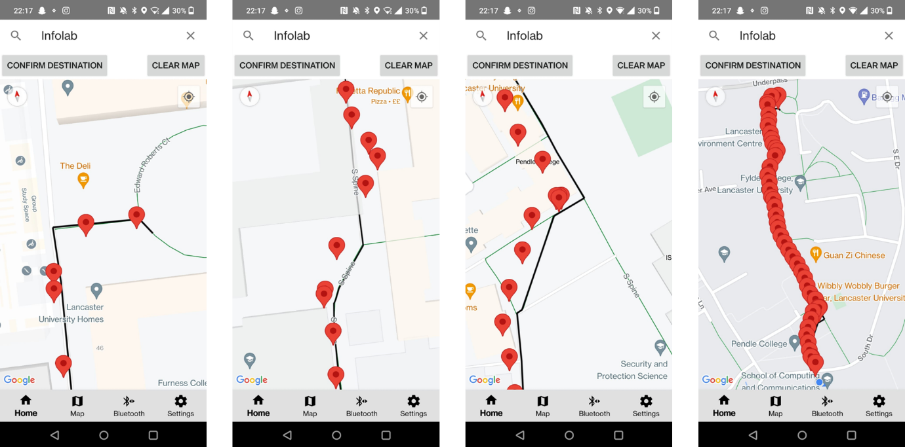

Figure ?: Screenshots of Participant 1’s experiment.

# 7. Conclusion

Sum up what ive done. Repcap

Review of aims and objectives – did I achieve them or how much did it not achieve

Learning process – what you learned. What went wrong and why

* Talk about how I had to learn circuitpython and maybe how I needed to learn how to implement google maps sdk
* Bluetooth

Future work – potential ideas / difficulties

Revisions of design and implementation – how much it varied

Changes from proposal

Final remarks

I can both use first person or 3rd person. I think that 1st person would be better to show exactly what I learned and how I think the project went.

## 7.1. Review of Aims

## 7.2. Future Work

## 7.3. Revisions of Design and Implementation

## 7.4. Changes from the Proposal

## 7.5.

# References

Arun, A.G. *BLE vs Wi-Fi: Which is Better for IoT Product Development?* Available at: <https://www.cabotsolutions.com/ble-vs-wi-fi-which-is-better-for-iot-product-development> .

Costanza, E., Inverso, S.A., Pavlov, E., Allen, R. & Maes, P. (2006) *eye-q: eyeglass peripheral display for subtle intimate notifications,* In: Helsinki, Finland, Proceedings of the 8th Conference on Human-Computer Interaction with Mobile Devices and ServicesNew York, NY, USA: Association for Computing Machinery.

Dr. William Goldstein (2013) *A Guide to Understanding Your Peripheral Vision.* Available at: <https://www.eyehealthweb.com/peripheral-vision/.>

Gruenefeld, U., Stratmann, T.C., Jung, J., Lee, H., Choi, J., Nanda, A. & Heuten, W. (2018) *Guiding Smombies: Augmenting Peripheral Vision with Low-Cost Glasses to Shift the Attention of Smartphone Users,* IEEE.

Lubos, P., Bruder, G., Ariza, O. & Steinicke, F. (2016) *Ambiculus: LED-based low-resolution peripheral display extension for immersive head-mounted displays,* In: Laval, France, Proceedings of the 2016 Virtual Reality International ConferenceNew York, NY, USA: Association for Computing Machinery.

Nakuo, T. & Kunze, K. (2016) *Smart glasses with peripheral vision display,* ACM.

Pielot, M., Poppinga, B., Heuten, W. & Boll, S. (2011) *6th senses for everyone! the value of multimodal feedback in handheld navigation aids,* In: Alicante, Spain, Proceedings of the 13th International Conference on Multimodal InterfacesNew York, NY, USA: Association for Computing Machinery.

R. Kusber, A. Q. Memon, D. Kroll & K. David (2015) *Direction Detection of Users Independent of Smartphone Orientations,* 2015 IEEE 82nd Vehicular Technology Conference (VTC2015-Fall).

figure in design: <https://cdn-learn.adafruit.com/assets/assets/000/105/130/original/EyeLights_PDF_export.pdf?1633457634>

# Appendix 1 – Project Proposal

Android (2023) *Bluetooth overview*. Available at: <https://developer.android.com/guide/topics/connectivity/bluetooth>.